UNIVERSITY OF EXETER

In 2021, 17338 animals were used for research at the University of Exeter. Some of these animals were housed at the University, and some were observed in the field.
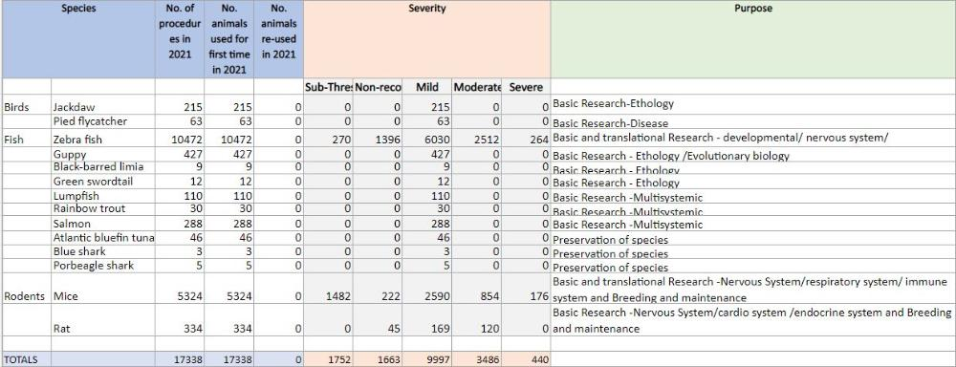

‌In 2020, 18008 animals were used for research at the University of Exeter. Some of these animals were housed at the University, and some were observed in the field.
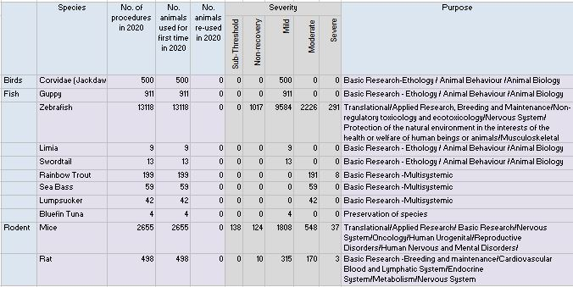

The University of Exeter used 27,237 animals in scientific procedures in 2017, including the
following:

Birds - 834 Fish - 24,979 Mice - 1,308 Other animals - 66 Rats - 50

